E6 SLOVENIA WITH MOUNTAINOUS SCENERY
Some data about the mountain part E6 Slovenia like start, end destination, day, km, hotel, pension, prices (look Picture 1).
Number | Start of destination | End of destination | day, km | Hotel, pension etc. | Prices in EUR
1 | Radelj border crossing | Mala Kopa | 1,30, | Partizanski dom, Mala Kopa | 21
2 | Mala Kopa | Sleme | 1,25 | Andrejev dom na Slemenu 03 589 51 54 | 13
3 | Sleme | Čreta nad Vranskim | 1,25 | Dom na Čreti (You can get a key in the nearby farm) | 7
4 | Čreta nad Vranskim | Trojane | 1,25 | Hotel Trojane, tel. +386 1 7233 610 | 21
5 | Trojane | Janče or Jevnica | 1,35  1,25 | Dom na Jančah 01 367 10 29.  Gostilna Kovač, Graška cesta 64, 1270 Litija, 041 684826, 01 898 00 00 . You must go with train from Jevnica to Litija, direction Zidani most (15 minutes from train station of Jevnica) | 21
6 | Janče | Grosuplje | 1, 25 | Gostilna Krpan 01 787 14 68 | 25
Look blog in Slovene language with pictures: http://www2.arnes.si/~sskrek6/traveller_journal/evropska_pespot_e6_slovenija.pdf
Use this webpage that you translate from Slovene to English

E7 SLOVENIA WITH MOUNTAINOUS SCENERY (Look picture 1).

Number | Start of destination | End of destination | day, km | Hotel, pension etc. | Prices in EUR
1 | Kobarid | Tolmin | 1, 30 | Hotel Krn 05/ 388 19 11 | 36
2 | Tolmin | Planina Razor | 1, 13 | Koča na planini Razor 051 632 720, info out from season Jože Mežnar 041/ 747 639
3 | Planina Razor | Petrovo Brdo | 1, 29 | Planinski dom Petrovo Brdo 041/ 320 966 (You must tell them that you come) | 17
4 | Petrovo Brdo | Koča na Blegošu | 1,21 | Koča na Blegošu 04/ 51 20 667
5 | Koča na Blegošu | Dom na Lubniku or Škofja Loka | 1,23 | Dom na Lubniku 04/ 512 05 01 (You must tell them that you come)  Škofja Loka (Hotel Garni, Kapucinski trg 17 GSM 00386 41874427) | 8  40

Look blog in Slovene language with pictures: http://www2.arnes.si/~sskrek6/traveller_journal/evropska_pespot_e7_slovenija.pdf
Use this webpage that you translate from Slovene to English

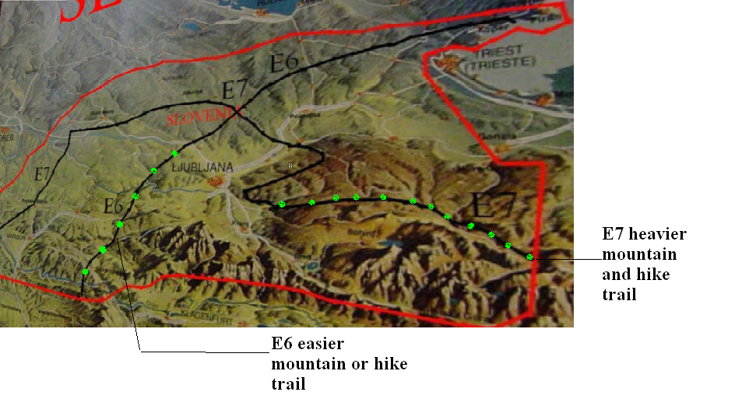
Picture 1: Mountain directions around E6 and E7
Look website about E6 and E7 generaly in Slovene in English language: http://eupoti.com

